|  |  |
| --- | --- |
| **EX.NO: 02** | **CONTROL STATEMENTS** |
| **DATE:** |

**PROGRAM 1:**

1.Develop a python program for finding the absolute value of a given number. This is always measured as positive number. This number is the distance of given number from the 0(Zero). The input value may be integer, float or complex number in Python. The absolute value of given number may be integer or float.

n = input("enter the number:")

value = eval(n)

absolute_value=abs(value)

print("Absolute value:", absolute_value)

**OUTPUT:**



**PROGRAM 2:**

2.Calculate the Total selling price after levying the GST (Goods and Service Tax) as CGST and SGST on sale. CGST (Central Govt. GST), SGST (State Govt. GST) .

**Sale amount CGST Rate SGST Rate**

0-50000 5% 5%

Above 50000 18% 18%

price=int(input("Enter the selling price:"))

if(0<price<=50000):

CGST=price*5/100

SGST=price*5/100

total_price=price+CGST+SGST

print("Total selling price:",total_price)

elif(price>50000):

CGST=price*18/100

SGST=price*18/100

total_price=price+CGST+SGST

print("Total selling price:",total_price)

else:

print("No tax")

**OUTPUT:**

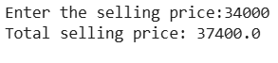

**PROGRAM 3:**

3.Write a Python program to construct the following pattern, using a nested for loop.

*

* *

* * *

* * * *

* * * * *

* * * *

* * *

* *

*

for i in range(1, 6):

for j in range(i):

print("*", end=" ")

print()

for i in range(4, 0, -1):

for j in range(i):

print("*", end=" ")

print()

**OUTPUT:**

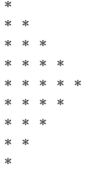

**PROGRAM 4:**

4.Write a Python program to guess a number between 1 and 9.

Note: The User is prompted to enter a guess. If the user guesses wrong, then the prompt appears again until the guess is correct. On a successful guess, the user will get a "Well guessed!" message, and the program will exit.

def guess_number():

s_n=4

n=int(input("Guess a number between 1 to 9:"))

while(n!=s_n):

n=int(input("Guess a number between 1 to 9:"))

else:

print("Well guessed!")

guess_number()

**OUTPUT:**

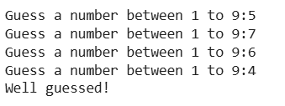

**PROGRAM 5:**

5.You have two streaming subscriptions and want to find out how much you spend each month and how much you could save if you switch to paying annually. Each subscription has a monthly cost and offers a discounted annual rate.

Write a Python program to calculate the total monthly cost for both subscriptions, the total annual cost if you continue paying monthly, and compare this with the yearly rates you would pay if you switch to annual payments. Finally, choose the yearly payment option to see how much you could save.

Test Case:

Input:

Service 1 = $10/month

Service 2 = $12/month

Annual Discount for Service 1 = $100

Annual Discount for Service 2 = $120

Expected Output:

Monthly Total: $22.00

Total Annual Cost without Discount: $264.00

Total Annual Discounted Cost: $220.00

Total Savings: $44.00

s_1=int(input("Enter the monthly cost of service 1:"))

s_2=int(input("Enter the monthly cost of service 2:"))

a_1=int(input("Enter the annual discount for service 1:"))

a_2=int(input("Enter the annual discount for service 2:"))

monthly_total=s_1+s_2

total_annual_cost=monthly_total*12

total_annual_discounted_cost=total_annual_cost-a_1-a_2

total_savings=a_1+a_2

print("Monthly Total:",monthly_total)

print("Total Annual Cost without Discount:",total_annual_cost)

print("Total Annual Discounted Cost:",total_annual_discounted_cost)

print("Total Savings:",total_savings)

**OUTPUT:**

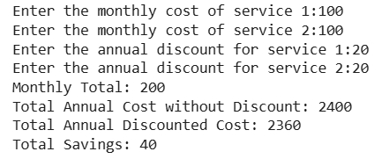

**PROGRAM 6:**

6.Write a Python program that iterates through integers from 1 to 50. For each multiple of three, print "Fizz" instead of the number; for each multiple of five, print "Buzz". For numbers that are multiples of both three and five, print "FizzBuzz"

for i in range(51):

if(i%3==0 and i%5==0):

print("FizzBuzz")

elif(i%3==0):

print("Fizz")

elif(i%5==0):

print("Buzz")

else:

print(i)

**OUTPUT:**

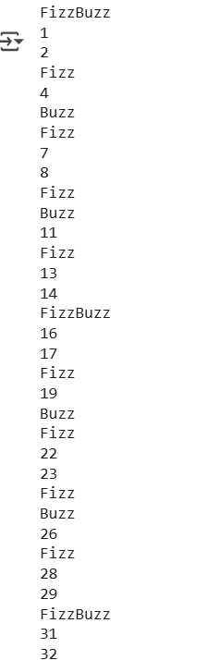

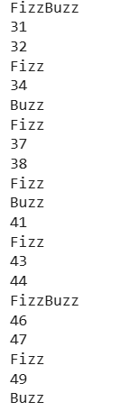

**PROGRAM 7:**

7.Write a Python program that takes two digits, m (row) and n (column) as input and generates a two-dimensional array. The element value in the i-th row and j-th column of the array should be i*j.

Note :  
i = 0,1.., m-1  
j = 0,1, n-1.

Test Data : Rows = 3, Columns = 4  
Expected Result : [[0, 0, 0, 0], [0, 1, 2, 3], [0, 2, 4, 6]]

m=int(input("Enter the number of rows:"))

n=int(input("Enter the number of columns:"))

array=[]

for i in range(m):

row=[]

for j in range(n):

row.append(i*j)

array.append(row)

print(array)

**OUTPUT:**

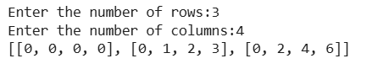

**PROGRAM 8:**

8.Write a Python program for Grade Classification

Scenario: A school system classifies grades as follows:

A (90 and above)

B (70 to 89)

C (50 to 69)

D (below 50)

Question: What grade will be assigned to a student who scores 85?

If the score is 92, what grade will the program output

n=int(input("Enter the marks you scored:"))

if(n>=90):

print("Your grade is A")

elif(n>=70):

print("Your grade is B")

elif(n>=50):

print("Your grade is C")

else:

print("Your grade is D")

**OUTPUT:**



**PROGRAM 9:**

1. Write a program that prints the multiplication table of a user-entered number up to 10.

n = int(input("Enter the number: "))

for i in range(11):

print(n, "*", i, "=", n * i)

**OUTPUT:**

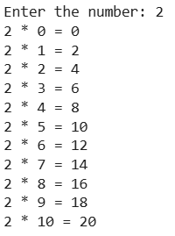

**PROGRAM 10:**

1. Write a Python program to check the validity of passwords input by users.

Validation :

At least 1 letter between [a-z] and 1 letter between [A-Z].

At least 1 number between [0-9].

At least 1 character from [$#@].

Minimum length 6 characters.

Maximum length 16 characters.

password=input("Enter the password:")

if(len(password)<6 or len(password)>16):

print("Invalid password")

else:

has_lower = False

has_upper = False

has_digit = False

has_special = False

for char in password:

if char.islower():

has_lower = True

elif char.isupper():

has_upper = True

elif char.isdigit():

has_digit = True

elif char in "$#@":

has_special = True

if has_lower and has_upper and has_digit and has_special:

print("Valid password")

else:

print("Invalid password (Missing required character types)")

**OUTPUT:**



|  |  |  |
| --- | --- | --- |
| **DEPARTMENT OF CSE** | | |
| Program | 10 |  |
| Output | 5 |  |
| Viva-Voce | 5 |  |
| Total | 20 |  |